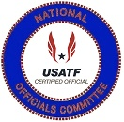 | USATF National Officials Committee  James Grey Award Criteria  The James Grey Award goes to an official who gives of themselves by leadership, fellowship, and developmental welfare of other officials through USATF training and its various official programs. | 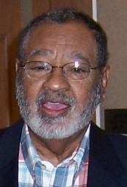

The James Grey Award was established at the Mid-Year National Officials Executive Committee Meeting in 2006 when the Maine Association came forward and wanted
to sponsor a National Officials Award. After a year of discussing the idea the National Officials Executive Committee established the following criteria to receive the
James Grey Award at the Mid-Year Meeting in 2007 . . .
- Must be a Certified USATF Track and Field Official for a ten (10) year period.
- Must be a National or Master Level official in good standing with the Association which they are certified, with the National Officials Committee and with USATF.
- Recognition by peers for excellence and achievement by an individual who by providing the leadership, setting the example, and going out of his/her way to help
in the development of others in the USATF Officials organization.

Nomination and Selection Process

All the nominees for the James Grey Award will be presented to the National Officials Executive Committee by the Awards Sub-Committee. The Awards Sub-Committee will
be divided into eleven areas with the committee members serving as the Area Representative for the assorted Association of USATF that make up each zone. The Awards
Committee Area Reps will canvass their respective areas through recommendations from other USATF Certified Officials, Association Officials Certification Chairs and from Association Presidents for candidates for the James Grey Award. Once approved by the Area Reps these names, along with letters of recommendation of his/her accomplishments
are to be sent to the National Officials Committee Vice-Chair of Awards who will then present them to the National Officials Executive Committee. The James Grey Award winner
will then be determined by a vote of the National Officials Committee Executive Committee at the annual mid-year meeting.
The five finalists and the winner of the James Grey Award will be presented at the Annual USATF Convention.

 |  | USATF National Officials Committee  James Grey Award  Recognition by peers for excellence and achievement by an individual who by providing the leadership, setting the example, and going out of his/her way to help in the development of others in the USATF Officials organization.  2007 through 2022  Sponsored by: Maine Association |  |  |  | 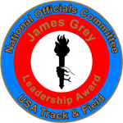
2007 Award Winner  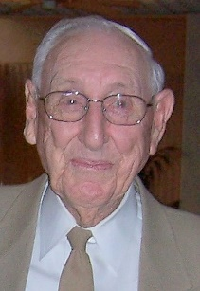  Charles Ruter  Fern Creek, Kentucky  Kentucky | 2008 Award Winner  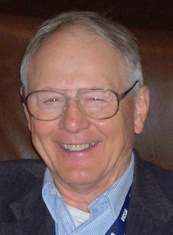  William Price  Smithburg, Maryland  Potomac Valley |  | 2009 Award Winner  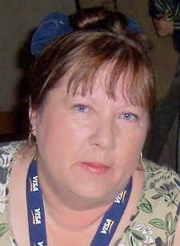  Val Foss  Canaan, Maine  Maine | 2010 Award Winner  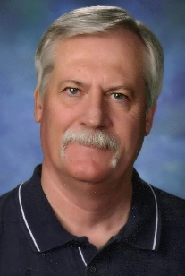  Jim Carlisle  Carrollton, Texas  Southwestern | 2011 Award Winner  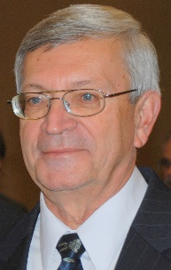  Len Krsak  Westerville, Ohio  Ohio
2012 Award Winner  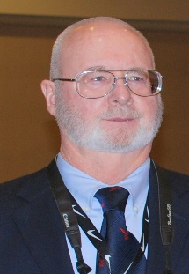  James Hume  San Mateo, California  Pacific | 2013 Award Winner  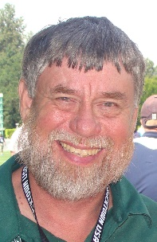  Dennis Olafson  Lebanon, Oregon  Oregon |  | 2014 Award Winner  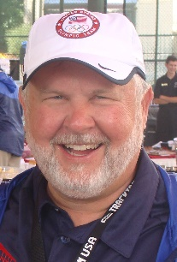  Mike Armstrong  Springdale, Arkansas  Arkansas | 2015 Award Winner  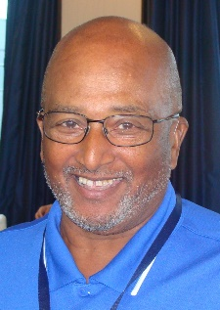  Roger Burbage  Raleigh, NC  North Carolina | 2016 Award Winner  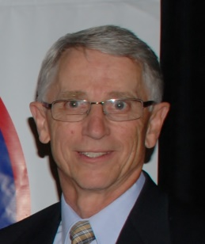  Richard Schornstein  Colorado Springs  Colorado
2017 Award Winner  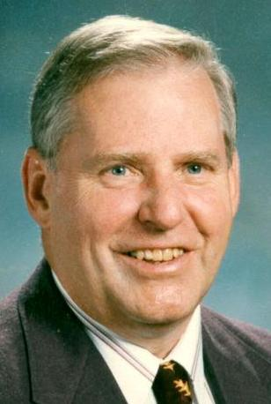  Donald Berry  Belmont, Maine  Maine | 2018 Award Winner  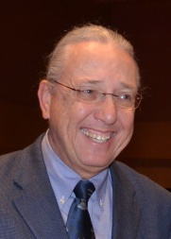  Robert Kern  Milwaukee, WI  Wisconsin |  | 2019 Award Winner  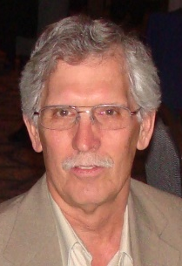  E. Scott Rose  Chillicothe, Ohio  Ohio | 2020 Award Winner  Irene Herman  San Francisco, Cal  Pacific | 2021 Award Winner  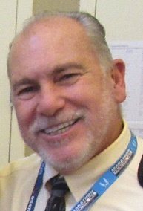  Mark Kostek  Fremont, Nebraska  Nebraska

 | USATF National Officials Committee  . James Grey Award  Recognition by peers for excellence and achievement by an individual who by providing the leadership, setting the example, and going out of his/her way to help in the development of others in the USATF Officials organization.  History of the Award | 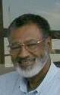

James Grey Area Winners and Nominees
Nominations for the James Grey Award are good for 3 Years.
An official can be re-nominated to be considered for another 3 Years.
***** Hall of Fame Inductees are no longer eligible for the James Grey Award *****
Those names in Blue have already received the Andy Bakjian Award for the various Associations.
Bold Print (Red)indicates they are currently nominated in their 3 Year Cycle and while the regular print has been nominated in the past but are outside their 3 Year Cycle and must be re-nominated
to be considered for the James Grey Award.
Those names in Red are Nominees for the 2022 James Grey Award
Paula Everdale  Area 1 . . . Awards Chair  Associations  Alaska, Inland Northwest, Pacific Northwest, Oregon and Snake River | Irene Herman  Area 2 . . . Awards Chair  Associations  Central California, Hawaii, Pacific,  San Diego-Imperial and Southern California | Terry Sudria  Area 3 . . . Awards Chair  Associations  Dakotas, Minnesota, Montana,  Nebraska and Wyoming
James Grey Award Winners in Area 1  Dennis Olafson (Oregon) . . . 2013  Nominations from Area 1 - Officials  Paul Bodenshot (Pacific Northwest)  Kenny Emrick (Pacific Northwest) – 2022  William Hickman (Pacific Northwest)  Mike Olsen (Oregon) - 2022  Sandy Paskin (Oregon)  NOC Hall of Fame  Darlene Hickman (Pacific Northwest) 2015  Dennis Olafson (Oregon) 2018  Kelly Rankin (Oregon) 2012  Lawrie Robertson (Pacific Northwest) 2011  Robert Springer (Pacific Northwest) 2018 | James Grey Award Winners in Area 2  James Hume (Pacific) . . . 2012  Irene Herman (Pacific) . . . 2020  Nominations from Area 2 - Officials  Dennis Boyle (Pacific)  Shirley Connors (Pacific)  NOC Hall of Fame  Andy Bakjian (Southern California) 2007  Richard Connors (Pacific) 2009  Leo Costanzo (Pacific) 2007  Horace Crow (Pacific) 2007  Jim Hume (Pacific) 2020  George Kleeman (Pacific) 2008  Lori Maynard (Pacific) 2008  Al Minturn (Southern California) 2010  John Murray (Pacific) 2020  Robert Podkaminer (Pacific) 2010  John Shirey (Pacific) 2019  Eugene Stemm (Southern California) 2012 | James Grey Award Winners in Area 3  Mark Kostek (Nebraska) . . . 2021  Nominations from Area 3 – Officials  None  NOC Hall of Fame  Dee Jensen (Dakotas ) 2007
Sherry Hott  Area 4 . . . Awards Chair  Associations  Arizona, Colorado, Nevada,  New Mexico and Utah | Mica Barton  Area 5 . . . Awards Chair  Associations  Border, Gulf, South Texas,  Southwestern and West Texas | Patricia Hanna  Area 6 . . . Awards Chair  Associations  Arkansas, Missouri Valley, Oklahoma,  Ozark and Southern
James Grey Award Winners in Area 4  Richard Schornstein (Colorado) . . . 2016  Nominations from Area 4 - Officials  Sherry Hott (Arizona)  Rhiny Williams (New Mexico) - 2022  NOC Hall of Fame  Lloyd Bert Garcia (New Mexico) 2021  Finn Hansen (Utah) 2007  Tom Hott (Arizona) 2017  Dan Reynolds (Arizona) 2014 | James Grey Award Winners in Area 5  Jim Carlisle (Southwestern) . . . 2010  Nominations from Area 5 - Officials  Mica Barton (Southwestern)  Stan Scott (West Texas)  NOC Hall of Fame  Herb “Diboll” Allen (Gulf) 2010  Chester Bradley (Southwestern) 2007  James Carlisle (Southwestern) 2016  Shirley Crowe (Gulf) 2008  John C.D. Drolla, Jr. (South Texas) 2011  Emmitt Griggs (Gulf) 2008  Delores Murray (Southwestern) 2020  Fred Newhouse (Gulf) 2020  Shelby Sharpe (Southwestern) 2015  Billy Walters (Southwestern) 2011  W. A. Wise (West Texas) 2009 | James Grey Award Winners in Area 6  Mike Armstrong (Arkansas) . . . 2014  Nominations from Area 6 - Officials  John Deardorff (Missouri Valley)  Gloria Louis (Southern)  Darren Muci (Missouri Valley) - 2022  NOC Hall of Fame  Mike Armstrong (Arkansas) 2021  Ginger Mulanax (Ozark) 2016  Tom Turk (Missouri Valley) 2008
Larry Henning  Area 7 . . . Awards Chair  Associations  Illinois, Indiana, Iowa,  Michigan and Wisconsin | Kenny Morton  Area 8 . . . Awards Chair  Associations  Kentucky, Lake Erie, Ohio,  Virginia and West Virginia | Gail Barna  Area 9 . . . Awards Chair  Associations  Alabama, Florida, Georgia, North Carolina,  South Carolina and Tennessee
James Grey Award Winners in Area 7  Robert Kern (Wisconsin) . . . 2018  Nominations from Area 7 - Officials  Peter Henkes (Wisconsin) - 2023  Richard Leutzinger (Iowa)  Mike Trego (Indiana) - 2022  Douglas Weir (Michigan) - 2022  NOC Hall of Fame  John Davis (Illinois) 2007  Carroll Deweese (Michigan) 2019  Gene Edmonds (Indiana) 2013  Win Eggers (Illinois) 2015  Rex Harvey (Iowa) 2010)  Keith Mitchell (Indiana) 2009  Eric Zemper (Michigan) 2014 | James Grey Award Winners in Area 8  Len Krsak (Ohio) . . . 2011  Scott Rose (Ohio) . . . 2019  Charles Ruter (Kentucky) . . . 2007  Nominations from Area 8 – Officials  William Anderson (Virginia)  Bill Boyd (Virginia)  Bill Buttermore (Ohio)  Harold “Lefty” Martin (Ohio) - 2023  Jennifer “JJ” Meadows (Kentucky) - 2022  Donna Messenger (West Virginia)  Elinor Tootle (Ohio)  Robert Stacey (Kentucky)  NOC Hall of Fame  Doug Allen (Kentucky) 2019  Ron Althoff (Ohio) 2008  Gordon Bocock (Kentucky) 2015  James Flanik (Lake Erie) 2014  Ed Gorman (Ohio) 2016  James Grey (Ohio) 2014  Karen Krsak (Ohio) 2016  Len Krsak (Ohio) 2014  Linda Melzer (Ohio) 2011  Richard Messenger (West Virginia) 2017  Kenny Morton (Kentucky) 2021  Scott Rose (Ohio) 2021  Charles Ruter (Kentucky) 2007 | James Grey Award Winners in Area 9  Roger Burbage (North Carolina) . . . 2015  Nominations from Area 9 - Officials  Lemuel “LB” Clayton (North Carolina) – 2022  Richard Forbid (North Carolina) - 2023  Rod Larsen (Florida)  Connie Talbert-McClinton (Alabama)  Houston Young (Alabama) - 2022  NOC Hall of Fame  John Blackburn (South Carolina) 2018  Roger Burbage (North Carolina) 2019  Richard Moss (Georgia) 2011  Jerome Perry (North Carolina) 2012  Murray Sanford (Georgia) 2008  Robert Tice (North Carolina) 2017  Stanley Underwood (Tennessee) 2009
Sue Polansky  Area 10 . . . Awards Chair  Associations  Long Island, Mid-Atlantic, New Jersey,  Niagara, Potomac Valley and Three Rivers |  | Greg Burnett  Area 11 . . . Awards Chair  Associations  Adirondack, Connecticut, Maine,  New England and New York
James Grey Award Winners in Area 10  William Price (Potomac Valley) . . . 2008  Nominations from Area 10 - Officials  Perry Jenkins (Niagara) - 2022  Allen Naylor (Potomac Valley) - 2023  James Pearce (Potomac Valley) - 2022  NOC Hall of Fame  Clarence Crawford (Three Rivers) 2008  Edward Koch (New Jersey) 2013  Mary Onken (New York) 2016  Sue Polansky (Long Island) 2014  Gary Westerfield (Long Island) 2013 |  | James Grey Award Winners in Area 11  Don Berry (Maine) . . . 2017  Val Foss (Maine) . . . 2009  Nominations from Area 11 – Officials  Fred Adler (Metropolitan)  Diane Wright (Connecticut) - 2022  NOC Hall of Fame  Don Berry (Maine) 2021  Laurie Boemker (New England) 2014  Ken Caouette (New England) 2007  David Katz (New York) 2017  Tom McTaggart (New York) 2015  Barbara Palmer (Adirondack) 2007  Patricia Rico (Metropolitan) 2007  Heliodoro Rico (Metropolitan) 2008  Warren Ring (Metropolitan) 2009

USATF National Officials Committee

. James Grey Award
Recognition by peers for excellence and achievement by an individual who by providing the leadership, setting the example, and going out of his/her way to help in the development of others in the USATF Officials organization.
2022 Nomination Form

Name of Person being Nominated: ___________________________________ Association: _______________

Nominated by: ___________________________ E-Mail ___________________________________________

Nomination Seconded: __________________ _________ E-Mail ____________________________________

Summary approved by Nominee: Yes No E-Mail ____________________________________

USAF Officials Certification # _____ Nominees First Year of Certification _________________________

Please type below why the nominee should be considered for the James Grey Award. Please include appropriate resume to justify this nomination

Date Nomination Received by Awards Chair: __________________
(Please Return Nomination Form with completed resume as soon as possible – August 31, 2022 Deadline)

