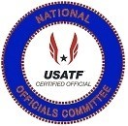 | USATF National Officials Committee  Horace Crow Award Criteria  The Horace Crow Award is given annually to an  Outstanding Field Official | 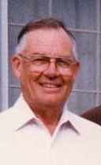
The Horace Crow Award was established at the National Convention in 1991. The National Officials Executive Committee established the following criteria to receive the Horace Crow Award at the Mid-Year Meeting in 2006 . . .
- Must be a Certified USATF Field Event Official for a ten (10) years.
- Must be a National or Master Level official in good standing with the Association which they are certified, with the National Officials Committee and with USATF.
- Recognition by peers for their betterment and devotion to track and field officiating for the various field events.

Nomination and Selection Process

All the nominees for the Horace Crow Award will be presented to the National Officials Executive Committee by the Awards
Sub-Committee. The Awards Sub-Committee will be divided into eleven areas with the committee members serving as the Area Representative for the assorted Association of USATF that make up each zone. The Awards Committee Area Reps will canvass their respective areas through recommendations from other USATF Certified Officials, Association Officials Certification Chairs and from Association Presidents for candidates for the Horace Crow Award. Once approved by the Area Reps these names, along with letters of recommendation of his/her accomplishments are to be sent to the National Officials Committee Vice-Chair of Awards who will then present them to the National Officials Executive Committee. The National Officials Executive Committee will narrow the nominees down to five finalists. The Horace Crow Award winner will then be determined by a vote of the National Officials Committee Executive Committee at the annual mid-year meeting. The five finalists and the winner of the Horace Crow Award will be presented at the Annual USATF Convention.

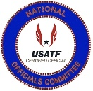 |  | USATF National Officials Committee  Horace Crow Award  The Horace Crow Award is given annually to an official that has given outstanding service throughout a career to the managing sports by taking officiating of field events to a higher level.  1992 – 2022  Sponsored by: Pacific Association
1992 Award Winner  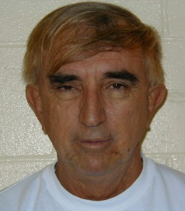  William Reaves  Ft. Lauderdale, Florida  Florida | 1993 Award Winner  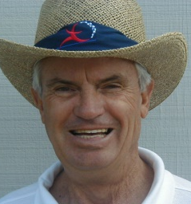  Edward Lankford  Taylor, Texas  Southwestern |  | 1994 Award Winner  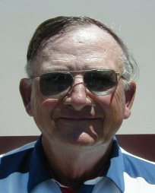  Gene Edmonds  Rennsselaer, Indiana  Indiana | 1995 Award Winner  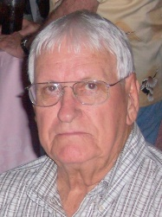  Shirley Crowe  Crosby, Texas  Gulf Association | 1996 Award Winner  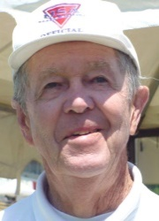  Carl Mosley  Valencia, California  Southern California
1996 Award Winner  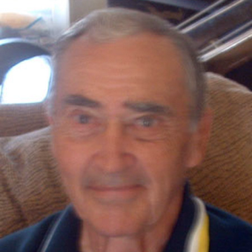  Richard McQuarrie  Victorville, California  Southern California | 1997 Award Winner  Keith Mitchell  Columbus, Indiana  Indiana |  | 1998 Award Winner  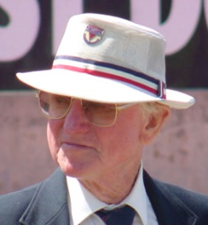  Fred Arnold  Los Angeles, California  Southern California | 1999 Award Winner  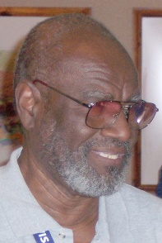  Emmitt Griggs  Houston, Texas  Gulf | 2000 Award Winner  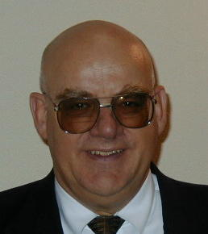  Finn Hansen  Salt Lake City, Utah  Utah
2000 Award Winner  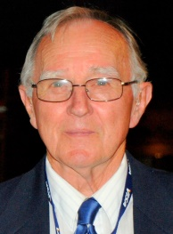  Eugene Stemm  Garden Grove, Cal  Southern California | 2001 Award Winner  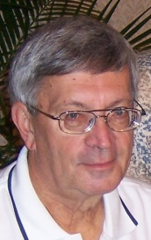  Len Krsak  Westerville, Ohio  Ohio |  | 2002 Award Winner  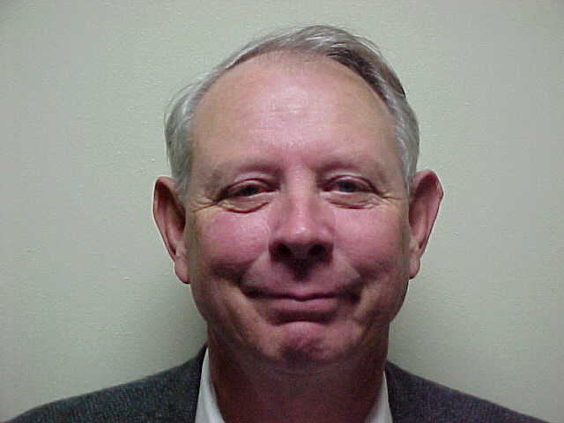  Billy Walters  Sherman, Texas  Southwestern | 2003 Award Winner  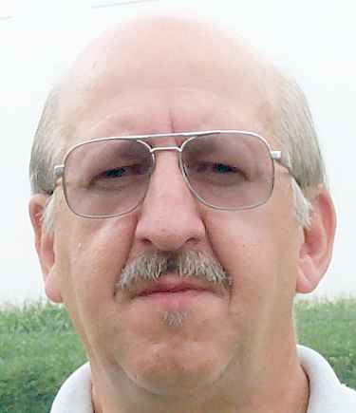  Doug Winemiller  Stewartstown, Pa  Mid Atlantic | 2003 Award Winner  Gloria Winemiller  Stewartstown, Pa  Mid Atlantic
2004 Award Winner  Stanley Underwood  Knoxville, Tennessee  Tennessee | 2005 Award Winner  Lane Dowell  Bremerton, Washington  Oregon |  | 2006 Award Winner  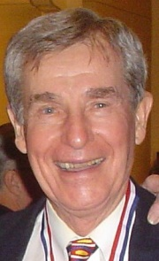  Chester Bradley  Dallas, Texas  Southwestern | 2007 Award Winner  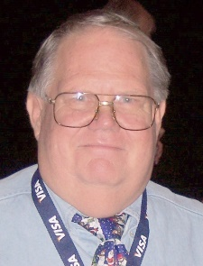  George Kleeman  Martinez, California  Pacific | 2008Award Winner  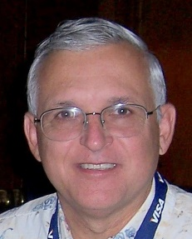  James Flanik  Northfield Central, Ohio  Lake Erie

2009 Award Winner  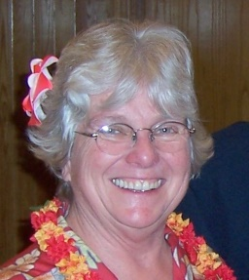  Win Eggers  Chicago, Illinois  Illinois | 2010 Award Winner  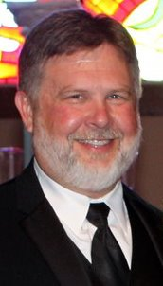  Mike Armstrong  Springdale, Arkansas  Arkansas | 2011 Award Winner  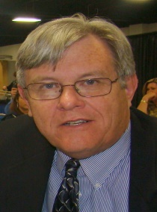  Doug Allen  Lexington, Kentucky  Kentucky | 2012 Award Winner  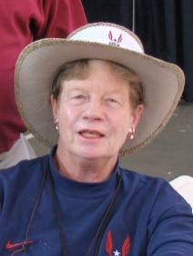  Shirley Connors  San Mateo, California  Pacific | 2013Award Winner  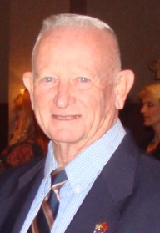  Ray Fitzhugh  Irvine, California  Pacific
2014 Award Winner  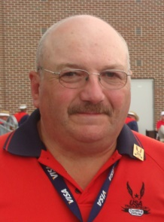  Robert Gidari  Deering, New Hampshire  New England | 2015 Award Winner  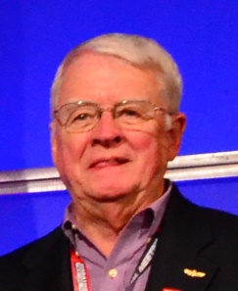  Eric Smith  Tallahassee, Florida  Florida | 2016 Award Winner  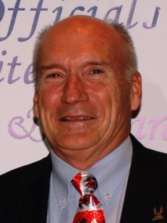  Richard Messenger  Weston, West Virginia  Virginia | 2017 Award Winner  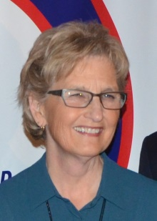  Kathleen McLymond  Williamson, New York  Niagara | 2018 Award Winner  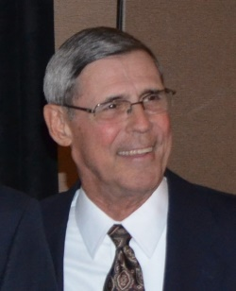  John Murray  Carmichael, CA  Pacific
2019 Award Winner  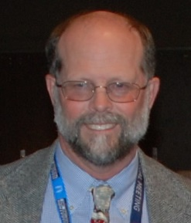  Patrick Lavelle  Holyoke, Mass.  New England | 2020 Award Winner  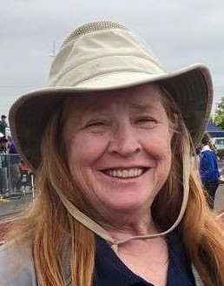  Paula Everdell  Graham, Wash.  Pacific Northwest | 2021 Award Winner  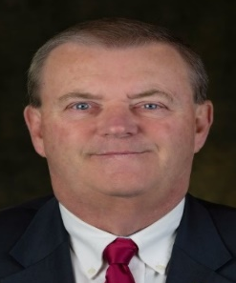  Mark Heckel  Hughesville, Penn  Three Rivers | 2022 Award Winner | 2023 Award Winner

USATF National Officials Committee

Horace Crow Award
The Horace Crow Award is given annually to an Outstanding Field Event Official
History of the Award

Horace Crow Area Winners and Nominees
Nominations for the Horace Crow Award are good for 3 Years.
An official can be re-nominated to be considered for another 3 Years.
***** Hall of Fame Inductees are no longer eligible for the Horace Crow Award *****
Those names in Blue have already received the Horace Crow Award for the various Associations.
Bold Print (Red) indicates they are currently nominated in their 3 Year Cycle and while the regular print has been nominated in the past but are outside their 3 Year Cycle and must be re-nominated to be
considered for the Horace Crow Award.
Those names in Red are Nominees for the 2020 Horace Crow Award
Paula Everdale  Area 1 . . . Awards Chair  Associations  Alaska, Inland Northwest, Pacific Northwest,  Oregon and Snake River | Irene Herman  Area 2 . . . Awards Chair  Associations  Central California, Hawaii, Pacific,  San Diego-Imperial and Southern California | Terry Sudria  Area 3 . . . Awards Chair  Associations  Dakotas, Minnesota, Montana,  Nebraska and Wyoming
Horace Crow Award Winners in Area 1  Lane Dowell (Oregon). . . 2005  Paula Everdell (Pacific Northwest) . . . 2020  Nominations from Area 1 Officials  Judith Christiansen (Pacific NW)  Patrick Duffey (Oregon)  Michael Grover (Oregon)  Mike Hinz (Inland Northwest)  Bill Kelly (Oregon) 2022  NOC Hall of Fame  Darlene Hickman (Pacific Northwest) 2015  Dennis Olafson (Oregon) 2018  Kelly Rankin (Oregon) 2012  Lawrie Robertson (Pacific Northwest) 2011  Robert Springer (Pacific Northwest) 2018 | Horace Crow Award Winners in Area 2  Carl Mosley (Southern California) . . . 1996  Richard McQuarrie (Southern California) 1996  Fred Arnold (Southern California) . . . 1998  Eugene Stemm (Southern California) . . . 2000  George Kleeman (Pacific) . . . 2007  Shirley Connors (Pacific) . . . 2012  Ray Fitzhugh (Pacific) . . . 2013  John Murray (Pacific) . . . 2018  Nominations from Area 2 Officials  Phil Leake – Pacific 2022  NOC Hall of Fame  Andy Bakjian (Southern California) 2007  Richard Connors (Pacific) 2009  Leo Costanzo (Pacific) 2007  Horace Crow (Pacific) 2007  Jim Hume (Pacific) 2020  George Kleeman (Pacific) 2008  Lori Maynard (Pacific) 2008  Al Minturn (Southern California) 2010  John Murray (Pacific) 2020  Robert Podkaminer (Pacific) 2010  John Shirey (Pacific) 2019  Eugene Stemm (Southern California) 2012 | Horace Crow Award Winners in Area 3  None  ~ ~ ~ ~ ~  Nominations from Area 3 Officials  None  NOC Hall of Fame  Dee Jensen (Dakotas) 2007
Sherry Hott  Area 4 . . . Awards Chair  Associations  Arizona, Colorado, Nevada,  New Mexico and Utah | Mica Barton  Area 5 . . . Awards Chair  Associations  Border, Gulf, South Texas,  Southwestern and West Texas | Patricia Hanna  Area 6 . . . Awards Chair  Associations  Arkansas, Missouri Valley, Oklahoma,  Ozark and Southern
Horace Crow Award Winners in Area 4  Finn Hansen (Utah) . . . 2000  Nominations from Area 4 Officials  Paul Gooris (New Mexico) 2022  Martin Johnson (Colorado) 2023  Richard Schornstein (Colorado) 2023  NOC Hall of Fame  Lloyd Bert Garcia (New Mexico) 2021  Finn Hansen (Utah) 2007  Tom Hott (Arizona) 2017  Dan Reynolds (Arizona) 2014 | Horace Crow Award Winners in Area 5  Edward Lankford (Southwestern). . . 1993  Shirley Crowe (Gulf) . . .1995  Emmitt Griggs (Gulf) . . . 1999  Billy Walters (Southwestern) . . . 2002  Chester Bradley (Southwestern) . . . 2006  Nomination from Area 5 Officials  George Adams (Southwestern) 2003  Randy Brown (Southwestern) 2002  Kyle Collier (West Texas) 2002  Barbara Collins (Southwestern) 2002  David Dunbar (Texas Southern)  Susan Feldman (Gulf) 2022  Frank Orzak (Gulf)  Stan Scott (West Texas) 2022  Hall of Fame  Herbert Allen – Gulf  Chester Bradley – Southwestern  Jim Carlisle – Southwestern  Shirley Crow – Gulf  John C.D. Drolla – Texas Southern  Emmitt Griggs - Gulf  Delores Murray – Southwestern  Fred Newhouse – Gulf  Shelby Sharpe – Southwestern  Billy Walters – Southwestern  W.A. Wise - West Texas | Horace Crow Award Winners in Area 6  Mike Armstrong (Arizona) . . . 2021  Nominations from Area 6 Officials  Connie Brand (Missouri Valley)  Jackie Callender (Southern)  Mike Davey (Missouri Valley) 2022  Bobby Jones (Arkansas)  Glyn Trigg (Southern)  David Williams (Arkansas)  William Wright (Oklahoma)  NOC Hall of Fame  Mike Armstrong (Arkansas) 2021  Ginger Mulanax (Ozark) 2016  Tom Turk (Missouri Valley) 2008
Larry Henning  Area 7 . . . Awards Chair  Associations  Illinois, Indiana, Iowa,  Michigan and Wisconsin | Kenny Morton  Area 8 . . . Awards Chair  Associations  Kentucky, Lake Erie, Ohio  Virginia and West Virginia | Gail Barna  Area 9 . . . Awards Chair  Associations  Alabama, Florida, Georgia, North Carolina,  South Carolina and Tennessee
Horace Crow Award Winners in Area 7  Edward Edmonds (Indiana) . . .1994  Keith Mitchell (Indiana) . . .1997  Win Eggers (Illinois) . . .2009  Nominations from Area 7 Officials  Richard Boyd (Indiana) 2003  Jay Gruenwald (Iowa) 2022  Tim Sweet (Iowa)  NOC Hall of Fame  John Davis (Illinois) 2007  Carroll Deweese (Michigan) 2019  Gene Edmonds (Indiana) 2013  Win Eggers (Illinois) 2015  Rex Harvey (Iowa) 2010)  Keith Mitchell (Indiana) 2009  Eric Zemper (Michigan) 2014 | Horace Crow Award Winners in Area 8  Len Krsak (Ohio) . . . 2001  James Flanik (Lake Erie) . . . 2008  Doug Allen (Kentucky) . . .2011  Richard Messenger (West Virginia) . . . 2016  Nominations from Area 8 Officials  Jeffrey Bauer (Ohio)  William Fyffe (West Virginia)  Sam Gorman (Ohio)  James Katos (Ohio) 2022  Mike Kempf (Ohio) 2023  Patty Mitchell (Ohio) 2022  Frank Newton (Kentucky) 2022  Mike Nissenbaum (Ohio) 2022  NOC Hall of Fame  Doug Allen (Kentucky) 2019  Ron Althoff (Ohio) 2008  Gordon Bocock (Kentucky) 2015  James Flanik (Lake Erie) 2014  Ed Gorman (Ohio) 2016  James Grey (Ohio) 2014  Karen Krsak (Ohio) 2016  Len Krsak (Ohio) 2014  Linda Melzer (Ohio) 2011  Richard Messenger (West Virginia) 2017  Kenny Morton (Kentucky) 2021  Scott Rose (Ohio) 2021  Charles Ruter (Kentucky) 2007 | Horace Crow Award Winners in Area 9  William Reeves (Florida) . . . 1992  Stanley Underwood (Tennessee) . . . 2004  Nominations from Area 9 Officials  Bruce Borden (Tennessee)  Jo Burrows (North Carolina)  Gerald Mullins (Florida)  Zina Parker (North Carolina) 2022  Tom Shinnick (Georgia) 2023  Bob Turner (Florida) 2022  Anthony Wayne (North Carolina)  Stephen West (Florida)  NOC Hall of Fame  John Blackburn (South Carolina) 2018  Roger Burbage (North Carolina) 2019  Richard Moss (Georgia) 2011  Jerome Perry (North Carolina) 2012  Murray Sanford (Georgia) 2008  Robert Tice (North Carolina) 2017  Stanley Underwood (Tennessee) 2009
Susan Polansky  Area 10 . . . Awards Chair  Associations  Long Island, Mid-Atlantic, New Jersey,  Niagara, Potomac Valley and Three Rivers | 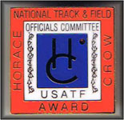 | Greg Burnett  Area 11 . . . Awards Chair  Associations  Adirondack, Connecticut, Maine  New England and New York
Horace Crow Award Winners in Area 10  Doug Winemiller (Mid Atlantic) . . . 2003  Gloria Winemiller (Mid Atlantic) . . . 2003  Kathy McLymond (Niagara) . . . 2017  Mark Heckel (Three Rivers) . . . 2021  Nominations from Area 10 - Officials  Larry Callahan (Niagara)  Sebastian Cianci (Potomac Valley) 2022  Paul Kosek (Niagara) 2022  Robert Norwood (Potomac Valley) 2022  William Pollinger (New Jersey)  Wayne Smith (New Jersey) 2023  Hall of Fame  Clarence Crawford – Three Rivers  Edward Koch – New Jersey  Susan Polansky – Long Island  Gary Westerfield – Long Island |  | Horace Crow Award Winners in Area 11  Bob Gidari (New England) . . . 2014  Patrick Lavelle (New England) . . . 2019  Nominations from Area 11 - Officials  Joseph Bullock (New England) 2002  Nicole Bullock (New England) 2002  Ollie Bunch (Adirondack)  William “Skip” Earle (New York)  Val Foss (Maine)  Robert Gourley (New England)  Tom Heisey (New York)  Lance Turley (Maine)  Hall of Fame  Don Berry - Maine  Laurie Boemker – New England  Ken Caouette – New England  David Katz – New York  Thomas McTaggert – New York  Mary Onken – New York  Barbara Palma – Adirondack  Heliodoro Rico – Metropolitan  Patricia Rico – Metropolitan  Warren Ring - Metropolitan

USATF National Officials Committee

Horace Crow Award
The Horace Crow Award is given annually to an Outstanding Field Event Official
Nomination Form . . . 2022

Name of Person being Nominated: ___________________________________ Association: _______________

Nominated by: ___________________________ E-Mail ___________________________________________

Nomination Seconded: __________________ _________ E-Mail ____________________________________

Summary approved by Nominee: Yes No E-Mail ____________________________________

USAF Officials Certification # _____ Nominees First Year of USATF Certification _________________________

Please type below why the nominee should be considered for the Horace Crowe Award. Please include appropriate resume to justify this nomination

Date Nomination Received by Awards Chair: __________________
(Please Return Nomination Form with completed resume as soon as possible – August 31, 2022. Deadline)

