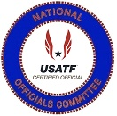 | USATF National Officials Committee  Charles Ruter Award Criteria  The Charles Ruter Award is given annually  to the  Outstanding Running Event Official
The Charles Ruter Award was established at the National Convention in 1998. The National Officials Executive Committee established the following criteria
to receive the Charles Ruter Award at the Mid-Year Meeting in 2006 . . .
- Must be a Certified USATF Running Event Official for a ten (10) year.
- Must be a National or Master Level official in good standing with the Association which they are certified, with the National Officials Committee
and with USATF.
- Recognition by peers for their betterment and devotion to track and field officiating in the area of running events.

Nomination and Selection Process

All the nominees for the Charles Ruter Award will be presented to the National Officials Executive Committee by the Awards Sub-Committee. The Awards Sub-Committee will be divided into eleven areas with the committee members serving as the Area Representative for the assorted Association of USATF that make up each zone. The Awards Committee Area Reps will canvass their respective areas through recommendations from other USATF Certified Officials, Association Officials Certification Chairs and from Association Presidents for candidates for the Charles Ruter Award. Once approved by the Area Reps these names, along with letters of recommendation of his/her accomplishments are to be sent to the National Officials Committee Vice-Chair of Awards who will then present them to the National Officials Executive Committee. The Charles Ruter Award winner will then be determined by a vote of the National Officials Committee Executive Committee at the annual mid-year’s meeting. The five finalists and the winner of the Charles Ruter Award will be presented at the Annual USATF Convention.

USATF National Officials Committee

Charles Ruter Award
The Charles Ruter Award is given annually to an official that has given outstanding service throughout a career to the managing sports by taking officiating of running events to a higher level.
1998 – 2022
Sponsored by: Kentucky Association
1998 Award Winner  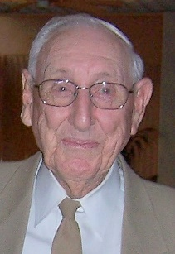  Charles Ruter  Fern Creek, Kentucky  Kentucky | 1999 Award Winner  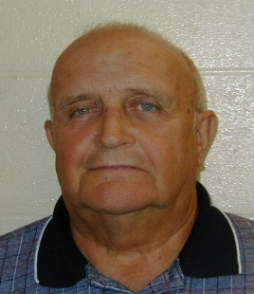  John Hickman  Columbus, Ohio  Ohio |  | 2000 Award Winner  Warren Ring  Brooklyn, New York  Metropolitan | 2001 Award Winner  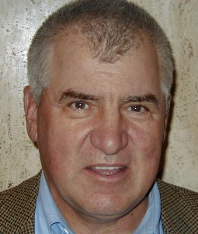  Richard Connors  San Mateo, California  Pacific | 2002 Award Winner  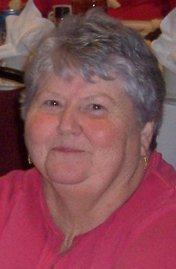  Ginger Mulanax  Florissant, Missouri  Ozark
2003 Award Winner  Dan Reynolds  Tucson, Arizona  Arizona | 2004 Award Winner  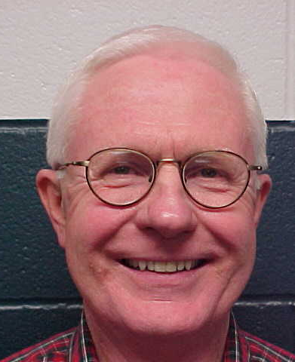  Shelby Sharpe  Fort Worth, Texas  Southwestern |  | 2005 Award Winner  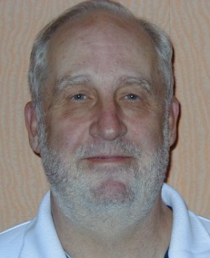  Fred Adler  Stoney Point, NY  Metropolitan | 2005 Award Winner  William Buttermore  Westlake, Ohio  Ohio | 2006 Award Winner  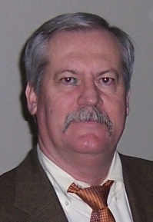  Jim Carlisle  Carrollton, Texas  Southwestern
2007 Award Winner  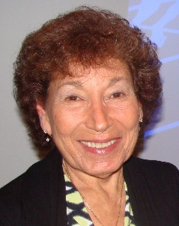  Sue Polansky  Plainview, New York  Long Island | 2008 Award Winner  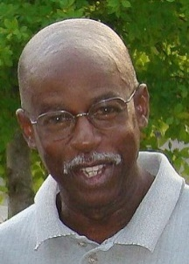  Kenny Morton  Louisville, Kentucky  Kentucky |  | 2009 Award Winner  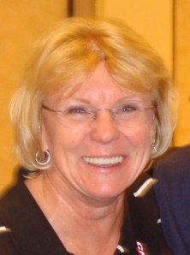  Karen Krsak  Columbus, Ohio  Ohio | 2010 Award Winner  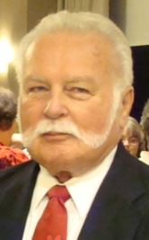  Fred Thomas  Johnstown, Ohio  Ohio | 2010 Award Winner  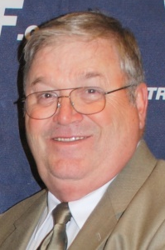  Gordon Bocock  Somerset, Kentucky  Kentucky
2011 Award Winner  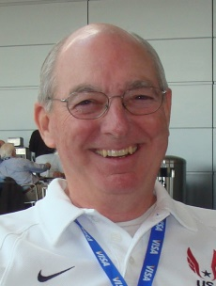  Tom Hott  Leitchfield, Illinois  Ozark | 2012 Award Winner  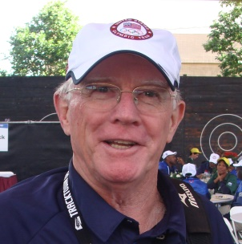  Tom McTaggert  Sloatsburg, New York  New York |  | 2013 Award Winner  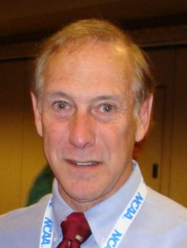  Bob Podkaminer  Santa Rosa, California  Pacific | 2014 Award Winner  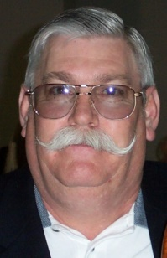  James McKee  Turner Station, Ky  Kentucky | 2015 Award Winner  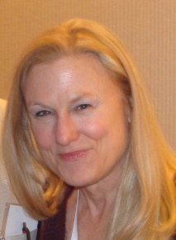  Laurie Boemker  Cranston, RI  New England
2016 Award Winner  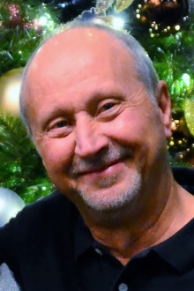  Rory Osborne  Davis, California  Pacific Association | 2017 Award Winner  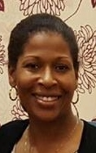  Tiffany Banks Chin Aleong  Frisco, Texas  Southwestern |  | 2018 Award Winner  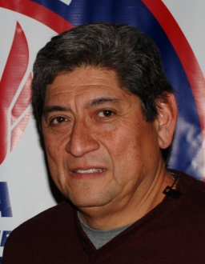  Lloyd “Bert” Garcia  Albuquerque, NM  New Mexico | 2019 Award Winner  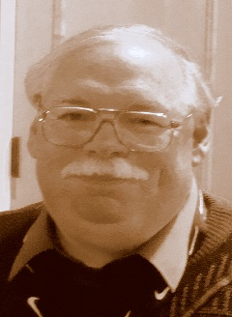  Larry Henning  Flora, Indiana  Indiana | 2020 Award Winner  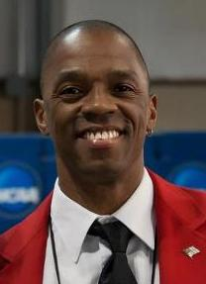  Raymond Pierre  Waco, Texas  Southwestern
2021 Award Winner  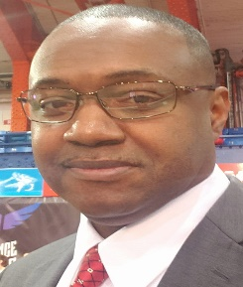  Lloyd Cornelius  Brooklyn, New York  New York Association | 2022 Award Winner

USATF National Officials Committee

. Charles Ruter Award
The Charles Ruter Award is given annually
to the Outstanding Running Event Official
1998 - 2022
History of the Award

Charles Ruter Area Winners and Nominees
Nominations for the Charles Ruter Award are good for 3 Years.
An official can be re-nominated to be considered for another 3 Years.
***** Hall of Fame Inductees are no longer eligible for the Charles Ruter Award *****
Those names in Blue have already received the Charles Ruter Award for the various Associations.
Bold Print (Red) indicates they are currently nominated in their 3 Year Cycle and while the regular print has been nominated in the past but are outside their 3 Year Cycle and must be re-nominated
to be considered for the Charles Ruter Award.
Those names in Red are Nominees for the 2022 Andy Bakjian Award
Paula Everdale  Area 1 . . . Awards Chair  Associations  Alaska, Inland Northwest, Pacific Northwest,  Oregon and Snake River | Irene Herman  Area 2 . . . Awards Chair  Associations  Central California, Hawaii, Pacific,  San Diego-Imperial and Southern California | Terry Sudri  Area 3 . . . Awards Chair  Associations  Dakotas, Minnesota, Montana,  Nebraska and Wyoming
Charles Ruter Award Winners in Area 1  None  Nominations from Area 1 - Officials  Nick Campbell (Oregon) - 2002  Kenny Emerick (Pacific Northwest) - 2022  William Hickman (Pacific Northwest)  Carol Langenbach (Pacific Northwest) - 2022  Bob Latham (Oregon) - 2022  Carol McLatchie (Oregon)  Jenifer Pieus (Oregon) - 2022  Bill Roe (Pacific Northwest)  NOC Hall of Fame  Darlene Hickman (Pacific Northwest) 2015  Dennis Olafson (Oregon) 2018  Kelly Rankin (Oregon) 2012  Lawrie Robertson (Pacific Northwest) 2011  Robert Springer (Pacific Northwest) 2018 | Charles Ruter Award Winners in Area 2  Richard Connors (Pacific) . . . 2001  Bob Podkaminer (Pacific) . . . 2013  Rory Osborne (Pacific) . . . 2016  ~ ~ ~ ~ ~  Nominations from Area 2 – Officials  Al Hernandez (Pacific) - 2022  Robert Marcus (Southern California)  Bob Rush (Pacific) - 2022  David Smith (Southern California)  NOC Hall of Fame  Andy Bakjian (Southern California) 2007  Richard Connors (Pacific) 2009  Leo Costanzo (Pacific) 2007  Horace Crow (Pacific) 2007  Jim Hume (Pacific) 2020  George Kleeman (Pacific) 2008  Lori Maynard (Pacific) 2008  Al Minturn (Southern California) 2010  John Murray (Pacific) 2020  Robert Podkaminer (Pacific) 2010  John Shirey (Pacific) 2019  Eugene Stemm (Southern California) 2012 | Charles Ruter Award Winners in Area 3  None  ~ ~ ~ ~ ~  Nominations from Area 3 - Officials  Terry Sudria (Dakotas)  NOC Hall of Fame  Dee Jensen (Dakotas ) 2007
Sherry Hott  Area 4 . . . Awards Chair  Associations  Arizona, Colorado, Nevada,  New Mexico and Utah | Mica Barton  Area 5 . . . Awards Chair  Associations  Border, Gulf, South Texas,  Southwestern and West Texas | Patricia Hanna  Area 6 . . . Awards Chair  Associations  Arkansas, Missouri Valley, Oklahoma,  Ozark and Southern
Charles Ruter Award Winners in Area 4  Lloyd Bert Garcia (New Mexico) . . . 2018  Tom Hott (Arizona) . . .2011  Dan Reynolds (Arizona) . . . 2003  Nominations from Area 4 - Officials  Gerard Collet (Utah) - 2022  Sherry Hott (Arizona) - 2023  3 . . . Susan Petrelli – Colorado  4 . . . Dale Robinson - Utah  NOC Hall of Fame  Lloyd Bert Garcia (New Mexico) 2021  Finn Hansen (Utah) 2007  Tom Hott (Arizona) 2017  Dan Reynolds (Arizona) 2014 | Charles Ruter Award Winners in Area 5  Tiffany Banks Aleong (Southwestern) . . . 2017  Jim Carlisle (Southwestern) . . . 2006  Raymond Pierre (Southwestern) . . . 2020  Shelby Sharpe (Southwestern) . . . 2004  Nominations from Area 5 - Officials  Omar De La Rosa (Texas Southern)  Ricky Williams (Texas Southern) - 2022  NOC Hall of Fame  Herb “Diboll” Allen (Gulf) 2010  Chester Bradley (Southwestern) 2007  James Carlisle (Southwestern) 2016  Shirley Crowe (Gulf) 2008  John C.D. Drolla, Jr. (South Texas) 2011  Emmitt Griggs (Gulf) 2008  Delores Murray (Southwestern) 2020  Fred Newhouse (Gulf) 2020  Shelby Sharpe (Southwestern) 2015  Billy Walters (Southwestern) 2011  W. A. Wise (West Texas) 2009 | Charles Ruter Award Winners in Area 6  Ginger Mulanax (Ozark) . . . 2002  Nominations from Area 6 - Officials  Stewart Blue (Southern)  Simon Caisson (Southern)  Vic Everett (Missouri Valley) - 2022  Karen Homan (Arkansas) - 2023  Lottie Keaton (Arkansas) - 2022  Robert Kreutz (Ozark)  Tom McBee (Arkansas)  Jim Shoemaker (Missouri Valley)  James Simmons (Southern)  NOC Hall of Fame  Mike Armstrong (Arkansas) 2021  Ginger Mulanax (Ozark) 2016  Tom Turk (Missouri Valley) 2008
Larry Henning  Area 7 . . . Awards Chair  Associations  Illinois, Indiana, Iowa  Michigan and Wisconsin | Kenny Morton  Area 8 . . . Awards Chair  Associations  Kentucky, Lake Erie, Ohio,  Virginia and West Virginia | Gail Barna  Area 9 . . . Awards Chair  Associations  Alabama, Florida, Georgia, North Carolina  South Carolina and Tennessee
Charles Ruter Award Winners in Area 7  Larry Henning (Indiana) . . . 2019  Nominations from Area 7 - Officials  Rob Buzaitis (Michigan)  Al Owens (Michigan) - 2023  Patrick Pretty (Wisconsin) - 2022  Lloyd David Stull (Indiana)  NOC Hall of Fame  John Davis (Illinois) 2007  Carroll Deweese (Michigan) 2019  Gene Edmonds (Indiana) 2013  Win Eggers (Illinois) 2015  Rex Harvey (Iowa) 2010)  Keith Mitchell (Indiana) 2009  Eric Zemper (Michigan) 2014 | Charles Ruter Award Winners in Area 8  Gordon Bocock (Kentucky) . . . 2010  Bill Buttermore (Ohio) . . . 2005  John Hickman (Ohio) . . . 1999  Karen Krsak (Ohio) . . . 2009  James McKee (Kentucky) . . .2014  Kenny Morton (Kentucky) . . . 2008  Charles Ruter (Kentucky) . . . 1998  Fred Thomas (Ohio) . . . 2010  Nominations from Area 8 – Officials  William Boyd (Virginia)  David Clark (Kentucky) - 2022  Larry Dixon (Ohio)  David Lawhorn (Kentucky) - 2022  Sandra Loveless (West Virginia) - 2023  Terri Tutt (Ohio) - 2023  NOC Hall of Fame  Doug Allen (Kentucky) 2019  Ron Althoff (Ohio) 2008  Gordon Bocock (Kentucky) 2015  James Flanik (Lake Erie) 2014  Ed Gorman (Ohio) 2016  James Grey (Ohio) 2014  Karen Krsak (Ohio) 2016  Len Krsak (Ohio) 2014  Linda Melzer (Ohio) 2011  Richard Messenger (West Virginia) 2017  Kenny Morton (Kentucky) 2021  Scott Rose (Ohio) 2021  Charles Ruter (Kentucky) 2007 | Charles Ruter Award Winners in Area 9  None  Nominations from Area 9 – Officials  Patrick Adair (North Carolina)  Lionel Bonck (Florida) - 2023  Arthur Carrington (North Carolina) - 2023  Albert Davis (North Carolina)  Rob Larsen (Florida)  Sam Kennedy (South Carolina) - 2023  Jeff Rigdon (Georgia) - 2022  Sam Smith (Tennessee)  NOC Hall of Fame  John Blackburn (South Carolina) 2018  Roger Burbage (North Carolina) 2019  Richard Moss (Georgia) 2011  Jerome Perry (North Carolina) 2012  Murray Sanford (Georgia) 2008  Robert Tice (North Carolina) 2017  Stanley Underwood (Tennessee) 2009
Sue Polansky  Area 10 . . . Awards Chair  Associations  Long Island, Mid-Atlantic, New Jersey,  Niagara, Potomac Valley and Three Rivers | 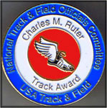 | Greg Burnett  Area 11 . . . Awards Chair  Associations  Adirondack, Connecticut, Maine,  New England and New York
Charles Ruter Award Winners in Area 10  Sue Polansky (Long Island) . . . 2007  Nominations from Area 10 - Officials  Perry Jenkins (Niagara)  Orretta “OJ” Johnson (Potomac Valley) - 2022  Tom Priester (Niagara) - 2023  Carla Ruff (Potomac Valley) - 2022  Howard Schmertz (Long Island)  NOC Hall of Fame  Clarence Crawford (Three Rivers) 2008  Edward Koch (New Jersey) 2013  Mary Onken (New York) 2016  Sue Polansky (Long Island) 2014  Gary Westerfield (Long Island) 2013 |  | Charles Ruter Award Winners in Area 11  Fred Adler (Metropolitan) . . . 2005  Laurie Boemker New England . . . 2015  Lloyd Cornelius New York . . . 2021  Tom McTaggert (New York) . . . 2012  Warren Ring (Metropolitan) . . . 2000  Nominations from Area 11 - Officials  Ron Daniel – Connecticut  James Wilcox – New England  NOC Hall of Fame  Don Berry (Maine) 2021  Laurie Boemker (New England) 2014  Ken Caouette (New England) 2007  David Katz (New York) 2017  Tom McTaggart (New York) 2015  Barbara Palmer (Adirondack) 2007  Patricia Rico (Metropolitan) 2007  Heliodoro Rico (Metropolitan) 2008  Warren Ring (Metropolitan) 2009

USATF National Officials Committee

Charles Ruter Award
The Charles Ruter Award is given annually
to the Outstanding Running Event Official

2022 Nomination Form

Name of Person being Nominated: ___________________________________ Association: _______________

Nominated by: ___________________________ E-Mail ___________________________________________

Nomination Seconded: __________________ _________ E-Mail ____________________________________

Summary approved by Nominee: Yes No E-Mail ____________________________________

USAF Officials Certification # _____ Nominees First Year of Certification _________________________

Please type below why the nominee should be considered for the Andy Bakjian Award. Please include appropriate resume to justify this nomination

Date Nomination Received by Awards Chair: __________________
Deadline for entries: August 31, 2022

