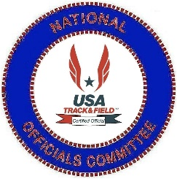 | USATF National Officials Committee  Andy Bakjian Award Criteria  The Andy Bakjian Award is given annually to an official that has given outstanding service throughout a career to the running sports by taking officiating track and field to a higher level.

Criteria for Nominations
Criteria for having the name of an official placed in nomination for the Andy Bakjian Outstanding Official Award . . . . .
- Must be a Certified USATF Official for a twelve (12) year period.
- Must be a Master Level Official in good standing with the Association which they are certified, in good standing with the National Officials Committee and in good standing with USATF.
- Must have officiated at National Championship Meets and/or International Championship Meets.
- Recognition by peers for excellence and achievement in track and field officiating.
- Recognition by peers for their betterment and devotion to track and field officiating.
- The Andy Bakjian Outstanding Official Award cannot be a posthumous award.

Nomination and Selection Process

The procedure to nominate an individual for the Andy Bakjian Outstanding Official Award is as follows . . .
- Nomination forms will be e-mailed to each member of the National Officials Committee and to the Officials Certification Chair of each Association on August 1st of each year. They must be returned to the National Officials Committee Vice-Chair of Awards by August 30th. The nomination forms must include the name of the individual being nominated along with verified statements of his/her accomplishments.
- All Nominees must endorse the statement of accomplishments to verify the validity of the contents presented by the individual doing the original nomination.
- If there are more than ten nominees, their credentials and statements of accomplishments will be sent to the National Officials Awards Sub-Committee. By secret ballot, the Awards Sub-Committee will select the ten names to be placed on the final ballot.

The procedure for final selection for the individual that will receive the Andy Bakjian Outstanding Official Award is as follows. . .
- The final ballot will be e-mailed to the following or October 1st and the ballot must be returned by October 31st.
- National Officials Committee Executive Committee
- Association Officials Certification Chairs
- At-Large Members
- Athlete’s Representatives
- Chairmen Emeritus
- National Liaison Officers
- National Officials Committee Representatives
- NOC Area Awards Committees

(The individuals that make up the above group will vote in the following manner. The ranking will be a one for your first choice, a two for your second choice and so forth and your tenth choice will receive a ten and be your final choice. All ten places must be voted on to be an official ballot. The voting will be tallied like a cross country meet in that when you place a number 1 beside a person’s name, they will receive 1 point while a 10 will give the individual 10 points. The votes will be tallied by the National Officials Committee Vice-Chair of Awards and the individual receiving the fewest number of points will be the winner of the Andy Bakjian Outstanding Official Award and presented at the Annual USATF Convention.

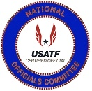 | USATF National Officials Committee  Andy Bakjian Award  The Andy Bakjian Award is given annually to an official that has given outstanding service throughout a career to the managing sports by taking officiating athletics to a higher level.  1982 – 2021  Sponsored by: Southern California Association
1982 Award Winner  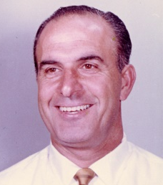  Andy Bakjian  Southern California |  | 1983 Award Winner  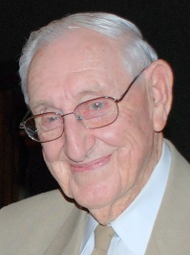  Charles Ruter  Kentucky | 1984 Award Winner  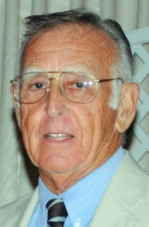  Ken Caouette  New England | 1985 Award Winner  Jack Milne  Mid-Atlantic | 1986 Award Winner  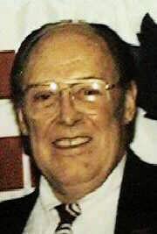  Hugh Norman  Iowa
1987 Award Winner  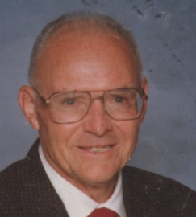  Hal Cranfield  Tennessee |  | 1988 Award Winner  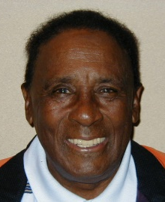  Clarence Crawford  Three Rivers | 1989 Award Winner  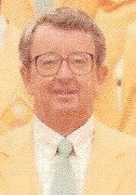  Jerome Perry  North Carolina | 1990 Award Winner  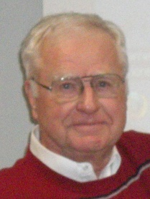  Ron Althoff  Ohio | 1991 Award Winner  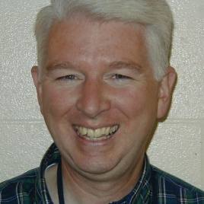  Lawrie Robertson  Pacific Northwest
1992 Award Winner  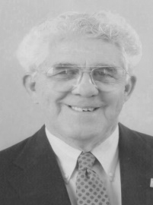  Bill Hartz  Kentucky |  | 1993 Award Winner  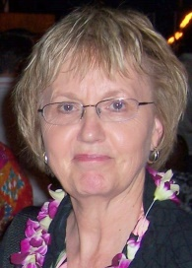  Dee Jensen  Dakotas | 1994 Award Winner  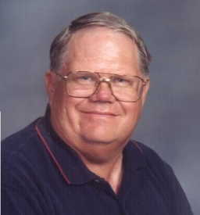  George Kleeman  Pacific | 1995 Award Winner  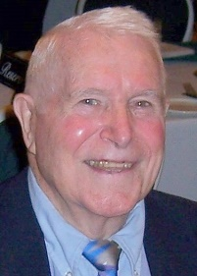  Leo Costanzo  Pacific | 1996 Award Winner  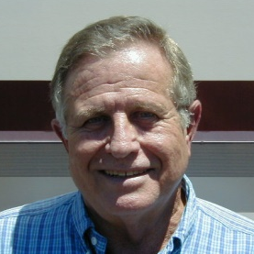  Rhea Warren  Florida
1997 Award Winner  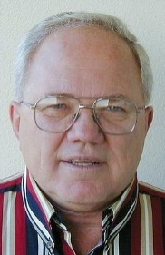  John Davis  Illinois |  | 1998 Award Winner  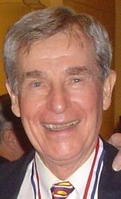  Chester Bradley  Southwestern | 1999 Award Winner  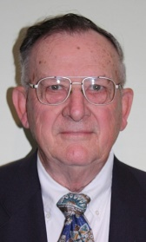  Gene Edmonds  Indiana | 2000 Award Winner  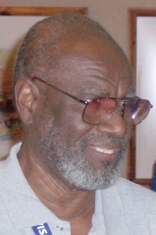  Emmitt Griggs  Gulf | 2001 Award Winner  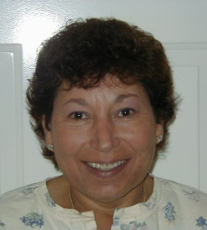  Sue Polansky  Long Island
2002 Award Winner  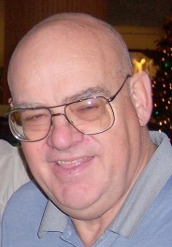  Finn Hansen  Utah |  | 2003 Award Winner  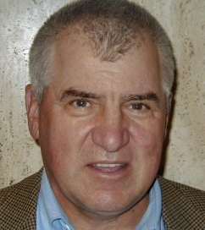  Dick Connors  Pacific | 2004 Award Winner  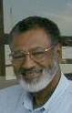  Jim Grey  Ohio | 2005 Award Winner  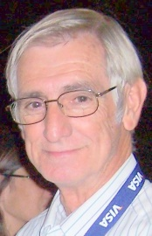  Murray Sanford  Georgia | 2006 Award Winner  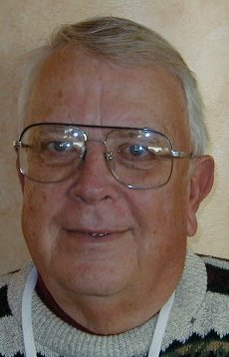  Keith Mitchell  Indiana
2007 Award Winner  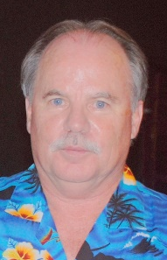  Dan Reynolds  Arizona |  | 2008 Award Winner  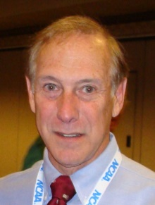  Bob Podkaminer  Pacific | 2009 Award Winner  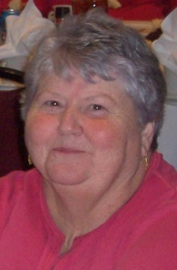  Virginia Mulanax  Ozark | 2010 Award Winner  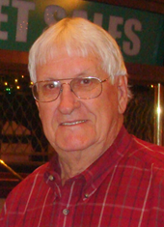  Shirley Crowe  Gulf | 2011 Award Winner  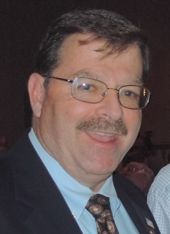  Ed Gorman  Ohio
2012 Award Winner  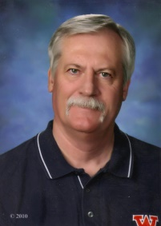  Jim Carlisle  Southwestern |  | 2013 Award Winner  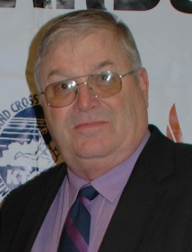  Gordon Bocock  Kentucky | 2014 Award Winner  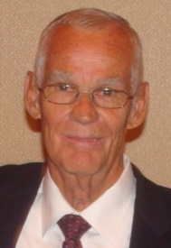  Richard Moss  Georgia | 2015 Award Winner  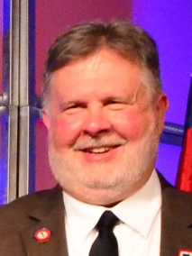  Mike Armstrong  Arkansas | 2016 Award Winner  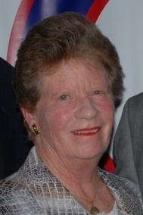  Shirley Connors  Pacific
2017 Award Winner  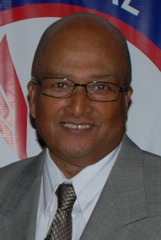  Roger Burbage  North Carolina |  | 2018 Award Winner  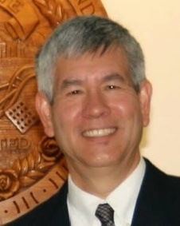  Justin Kuo  New England | 2019 Award Winner  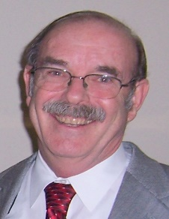  David Snyder  Southern California | 2020 Award Winner  Mark Kostek  Nebraska | 2021 Award Winner  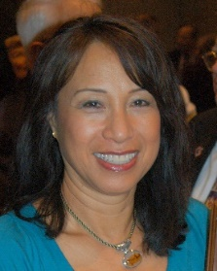  Irene Herman  Pacific

Andy Bakjian Area Winners and Nominees
Nominations for the Andy Bakjian Award are good for 3 Years.
An official can be re-nominated to be considered for another 3 Years.
***** Hall of Fame Inductees are no longer eligible for the Andy Bakjian Award *****
Those names in Blue have already received the Andy Bakjian Award for the various Associations.
Bold Print indicates they are currently nominated in their 3 Year Cycle and while the regular print has been nominated in the past but are outside their 3 Year Cycle and must be re-nominated to be considered for the Andy Bakjian Award.
Those names in Red are Nominees for the 2022 Andy Bakjian Award
Paula Everdale  Area 1 . . . Awards Chair  Associations  Alaska, Inland Northwest, Pacific Northwest, Oregon and Snake River | Irene Herman  Area 2 . . . Awards Chair  Associations  Central California, Hawaii, Pacific,  San Diego-Imperial and Southern California | Terry Sudria  Area 3 . . . Awards Chair  Associations  Dakotas, Minnesota, Montana,  Nebraska and Wyoming
Andy Bakjian Award Winners in Area 1  Lawrie Robertson (Pacific Northwest) . . 1991  ~ ~ ~ ~ ~  Nominations from Area 1  Paul Bodenshot – Pacific Northwest - 2023  William Hickman (Pacific Northwest)  Jerry Westfall (Oregon)  NOC Hall of Fame  Darlene Hickman (Pacific Northwest) 2015  Dennis Olafson (Oregon) 2018  Kelly Rankin (Oregon) 2012  Lawrie Robertson (Pacific Northwest) 2011  Robert Springer (Pacific Northwest) 2018 | Andy Bakjian Award Winners in Area 2  Andy Bakjian (Southern California) … 1982  George Kleeman (Pacific) … 1994  Leo Costanzo (Pacific) … 1995  Dick Connors (Pacific) … 2003  Bob Podkaminer (Pacific) … 2008  Shirley Connors (Pacific) … 2016  David Snyder (Southern California) … 2019  Irene Herman (Pacific) . . . 2021  ~ ~ ~ ~ ~  Nominations from Area 2  Dennis Boyle (Pacific Association) - 2022  Jim Skelly (San Diego-Imperial) - 2022  Leon Glover (Pacific)  Robert Seaman (Southern California)  NOC Hall of Fame  Andy Bakjian (Southern California) 2007  Richard Connors (Pacific) 2009  Leo Costanzo (Pacific) 2007  Horace Crow (Pacific) 2007  Jim Hume (Pacific) 2020  George Kleeman (Pacific) 2008  Lori Maynard (Pacific) 2008  Al Minturn (Southern California) 2010  John Murray (Pacific) 2020  Robert Podkaminer (Pacific) 2010  John Shirey (Pacific) 2019  Eugene Stemm (Southern California) 2012 | Andy Bakjian Award Winners in Area 3  Dee Jensen (Dakotas) … 1993  Mark Kostek (Nebraska) . . . 2020  ~ ~ ~ ~ ~  Nominations from Area 3  Michael Maryott – (Nebraska) – 2022  NOC Hall of Fame  Dee Jensen (Dakotas ) 2007
Sherry Hott  Area 4 . . . Awards Chair  Associations  Arizona, Colorado, Nevada,  New Mexico and Utah | Mica Barton  Area 5 . . . Awards Chair  Associations  Border, Gulf, South Texas,  Southwestern and West Texas | Patricia Hanna  Area 6 . . . Awards Chair  Associations  Arkansas, Missouri Valley, Oklahoma,  Ozark and Southern
Andy Bakjian Award Winners in Area 4  Finn Hansen (Utah) … 2002  Dan Reynolds (Arizona) … 2007  ~ ~ ~ ~ ~  Nominations from Area 4  Richard Schornstein (Colorado) - 2023  Rhiny Williams (New Mexico) - 2022  Dale Robinson (Utah)  NOC Hall of Fame  Lloyd Bert Garcia (New Mexico) 2021  Finn Hansen (Utah) 2007  Tom Hott (Arizona) 2017  Dan Reynolds (Arizona) 2014 | Andy Bakjian Award Winners in Area 5  Chester Bradley (Southwestern) … 1998  Emmitt Griggs (Gulf) … 2000  Shirley Crowe (Gulf) … 2010  Jim Carlisle (Southwestern) … 2012  ~ ~ ~ ~ ~  Nominations from Area 5  Tiffany Banks Chin Aleong (Southwestern) - 2022  Tommy Ratliff (West Texas) - 2022  NOC Hall of Fame  Herb “Diboll” Allen (Gulf) 2010  Chester Bradley (Southwestern) 2007  James Carlisle (Southwestern) 2016  Shirley Crowe (Gulf) 2008  John C.D. Drolla, Jr. (South Texas) 2011  Emmitt Griggs (Gulf) 2008  Delores Murray (Southwestern) 2020  Fred Newhouse (Gulf) 2020  Shelby Sharpe (Southwestern) 2015  Billy Walters (Southwestern) 2011  W. A. Wise (West Texas) 2009 | Andy Bakjian Award Winners in Area 6  Ginger Mulanax (Ozark) … 2009  Mike Armstrong (Arkansas) … 2015  ~ ~ ~ ~ ~  Nominations from Area 6  Steward Blue (Southern)  Simon Chiasson (Southern)  Gloria Louis (Southern)  James Simmons (Southern)  Henry Woods (Southern)  NOC Hall of Fame  Mike Armstrong (Arkansas) 2021  Ginger Mulanax (Ozark) 2016  Tom Turk (Missouri Valley) 2008
Larry Henning  Area 7 . . . Awards Chair  Associations  Illinois, Indiana, Iowa,  Michigan and Wisconsin | Kenny Morton  Area 8 . . . Awards Chair  Associations  Kentucky, Lake Erie, Ohio  Virginia and West Virginia | Gail Barna  Area 9 . . . Awards Chair  Associations  Alabama, Florida, Georgia, North Carolina,  South Carolina and Tennessee
Andy Bakjian Award Winners in Area 7  Hugh Norman (Iowa) … 1986  John Davis (Illinois) … 1997  Gene Edmonds (Indiana) … 1999  Keith Mitchell (Indiana) … 2006  ~ ~ ~ ~ ~  Nominations from Area 7  Carolyn Hill –(Iowa) - 2022  Patrick Pretty (Wisconsin) - 2022  Al Owens (Michigan)  NOC Hall of Fame  John Davis (Illinois) 2007  Carroll Deweese (Michigan) 2019  Gene Edmonds (Indiana) 2013  Win Eggers (Illinois) 2015  Rex Harvey (Iowa) 2010)  Keith Mitchell (Indiana) 2009  Eric Zemper (Michigan) 2014 | Andy Bakjian Award Winners in Area 8  Charles Ruter (Kentucky) … 1983  Ron Althoff (Ohio) … 1990  Bill Hartz (Kentucky) … 1992  Jim Grey (Ohio) … 2004  Ed Gorman (Ohio) … 2011  Gordon Bocock (Kentucky) … 2013  ~ ~ ~ ~ ~  Nominations from Area 8  Harold Jacobs (Kentucky) - 2022  Patricia Rouse (Kentucky) - 2022  Tom Jennings (West Virginia)  Fred Thomas (Ohio)  NOC Hall of Fame  Doug Allen (Kentucky) 2019  Ron Althoff (Ohio) 2008  Gordon Bocock (Kentucky) 2015  James Flanik (Lake Erie) 2014  Ed Gorman (Ohio) 2016  James Grey (Ohio) 2014  Karen Krsak (Ohio) 2016  Len Krsak (Ohio) 2014  Linda Melzer (Ohio) 2011  Richard Messenger (West Virginia) 2017  Kenny Morton (Kentucky) 2021  Scott Rose (Ohio) 2021  Charles Ruter (Kentucky) 2007  Eric Smith (Kentucky) 2020 | Andy Bakjian Award Winners in Area 9  Hal Cranfield (Tennessee) … 1987  Jerome Perry (North Carolina . . . 1989  Rhea Warren (Florida) … 1996  Murray Sanford (Georgia) … 2005  Dick Moss (Georgia) … 2014  Roger Burgage (North Carolina) … 2017  ~ ~ ~ ~ ~  Nominations from Area 9  Al Davis (North Carolina) - 2022  Clyde Crimmel (South Carolina)  Rhea Warren (Florida)  Anthony Wayne (North Carolina)  NOC Hall of Fame  John Blackburn (South Carolina) 2018  Roger Burbage (North Carolina) 2019  Richard Moss (Georgia) 2011  Jerome Perry (North Carolina) 2012  Murray Sanford (Georgia) 2008  Robert Tice (North Carolina) 2017  Stanley Underwood (Tennessee) 2009
Susan Polansky  Area 10 . . . Awards Chair  Associations  Long Island, Mid-Atlantic, New Jersey,  Niagara, Potomac Valley and Three Rivers |  | Greg Burnett  Area 11 . . . Awards Chair  Associations  Adirondack, Connecticut, Maine,  New England and New York
Andy Bakjian Award Winners in Area 10  Jack Milne (Mid Atlantic) … 1985  Clarence Crawford (Three Rivers) … 1988  Sue Polansky (Long Island) … 2001  ~ ~ ~ ~ ~  Nominations from Area 10  Andrew Boyajian (New Jersey) - 2022  Perry Jenkins (Niagara) - 2022  Kathy McLymond (Niagara) - 2022  William H. Smith (Potomac Valley) - 2023  Edward Callahan (Mid Atlantic)  William Jackson (Mid Atlantic)  Ronald McLean (New Jersey)  Lloyd McMillian (Potomac Valley)  Tom Priester (Niagara)  Alcmena White (Mid-Atlantic)  NOC Hall of Fame  Clarence Crawford (Three Rivers) 2008  Edward Koch (New Jersey) 2013  Mary Onken (New York) 2016  Sue Polansky (Long Island) 2014  Gary Westerfield (Long Island) 2013 |  | Andy Bakjian Award Winners in Area 11  Ken Caouette (New England) … 1984  Justin Kuo (New England) … 2018  ~ ~ ~ ~ ~  Nominations from Area 11  Fred Adler (New York) - 2022  Ron Boemker (New England)  NOC Hall of Fame  Don Berry (Maine) 2021  Laurie Boemker (New England) 2014  Ken Caouette (New England) 2007  David Katz (New York) 2017  Tom McTaggart (New York) 2015  Barbara Palmer (Adirondack) 2007  Patricia Rico (Metropolitan) 2007  Heliodoro Rico (Metropolitan) 2008  Warren Ring (Metropolitan) 2009

USATF National Officials Committee

Andy Bakjian Award
The Andy Bakjian Award is given annually to an official that has given outstanding service throughout a career to the running sports by taking officiating track and field to a higher level.
Nomination Form . . . . . 2022

Name of Person being Nominated: ___________________________________ Association: _______________

Nominated by: ___________________________ E-Mail ___________________________________________

Nomination Seconded: __________________ _________ E-Mail ____________________________________

Summary approved by Nominee: Yes No E-Mail ____________________________________

USAF Officials Certification # _____ Nominees First Year of USATF Certification _________________________

Please type below why the nominee should be considered for the Horace Crowe Award. Please include appropriate resume to justify this nomination

Date Nomination Received by Awards Chair: __________________
(Please Return Nomination Form with completed resume as soon as possible – August 31, 2022, Deadline)

