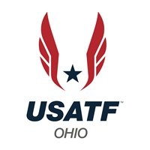

Ohio Association
Email Newsletter June 2022

From the President’s Lane
From the President
Greetings,
This year’s track and field season started off on a very soggy and most time a very cold start. I know many of us including myself dodged may raindrops and snowflakes. Besides the inclement weather this year seems to be getting back to a “new normal” of track and field season.
Many Ohio officials just completed the NCAA Championship in all 3 division. Over the days of competition, I heard lots of good feedback regarding the GREAT officiating at all three divisions by our Ohio officials. It is always a good feeling at this level of competition to have an athlete that recognizes an official from a regular college meet come up to that official and tell them “Now I know it going to be a good meet because you’re on the crew”. This just shows the level of excellence the Ohio officials display at every meet whether it is just a small college meet, conference meet or a championship meet.
This summer will bring the World Athletics Outdoor Championship in July to Hayward Field at the University of Oregon in Eugene Oregon. Before that will be National Scholastic Athletics Foundation Outdoor Championship as well as the 2022 USA Track and Field Senior and U20 Outdoor Championship. Both will also commence on Hayward Field in June.
Good luck to all the Ohio Athletes traveling to Eugene. They will again see familiar faces of many Ohio officials that will be working these meets. “Ability is what you are capable of doing.
Motivation determines what you do. Attitude determines how well you do it.” Lou Holtz

Patty Mitchell
USATF Ohio Association President

Grow to Impact Grant

The Ohio Association of USATF has received $5000.00 for one year to grow membership and clubs within the Association. The Run, Jump, Throw Program will be part of the grant program offered to our youth athletes. The development of a campaign program will focus on over 18 and masters’ athletes and on bringing in new officials and new clubs.
The purpose of the grant is to help the Ohio Association to encourage, improve and promote the sport of Amateur Track & Field in the State of Ohio. Over the past several years the Association has seen both a decline in membership, establishment of new clubs and new officials. Over the past 4 years the Association saw a 33% decline in membership, 11 % decline in clubs and a 28% decline in officials.
Any member in the associate that would be interested in offering a program in their area of Ohio please contact Patty Mitchell president@ohio.usatf.org . You can find the grant proposal on our local website at ohio.usatf.org.

Ohio and Lake Erie Associations Recruiting Event
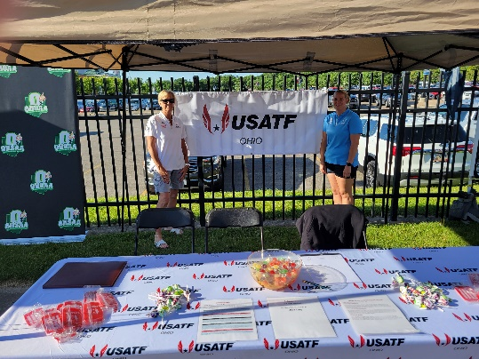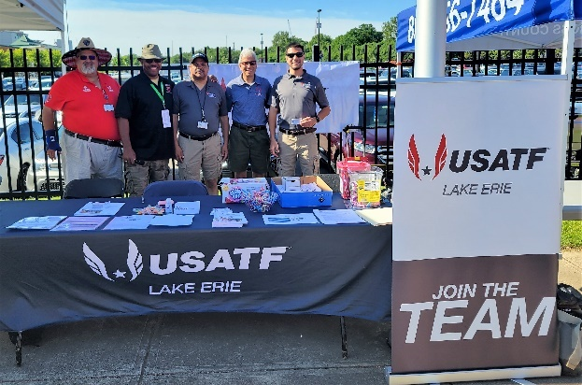
As part of the Grow to Impact Grant Program, the Ohio and Lake Erie Associations combined their efforts to reach out to athletes and spectators at this years Ohio High School Athletic Association’s (OHSAA) State Track and Field Meet held at The Ohio State University’s Jesse Owens Memorial Stadium, June 4^{th,} and 5th.
In coordination with OHSAA, members from both Associations manned a recruiting table to inform athletes and spectators who either participated in the meet or came to watch the action on the track or in the field of the opportunities of becoming a high school track & field official and also the opportunities that are available with USATF as an athlete or official.
As mentioned in the Grow to Impact Grant article above, the Association saw a decline in membership of 33%, a decline in club membership of 11% and a decline in officials of 28%. These are alarming statistics that we hope to reverse through this grant and events like the recruiting effort at the OHSAA State Track and Field Meet.
During the two days of the meet our Association representatives were able to talk to numerous athletes, parents, spectators, and coaches who were interested in learning more about USATF and the opportunities of joining could provide to them or their athletes. Everyone who worked the recruiting tent was enthusiastic about the interest expressed and they all hope to see some new faces joining the Ohio Association in the future as a result.

OREGON WELCOMES THE WORLD: JULY 15–24, 2022
Hello, World. Meet Oregon. The World Athletics Championships are coming to the United States for the first time ever.
WCH Oregon22 is an unmissable global experience taking place in the United States for the very first time. The best track and field athletes in the world are coming together in a celebration of diversity, human potential, and athletic achievement. This extraordinary showcase is taking center stage in the heart and home of the sport of track and field in the U.S: in Oregon, in Eugene, in Hayward Field at the University of Oregon.
Team USA, the world’s #1 team, will lay it all on the line on their home turf, in a setting that is both richly intimate and magnificently state-of-the-art. An incredible theater for the sport, the newly reimagined Hayward Field will be the epicenter of local, national, and global communities July 15–24, 2022.
Make sure you don’t miss a single glorious moment! Buy tickets here. Sign up for our newsletter to stay up to date on all the latest WCH Oregon22 information.

What can you find on the Associations Website?
If you are looking for information on events, membership, how to become involved in Race Walk or what age is considered Masters. If you are looking for coaches’ education courses or officiating opportunities. Go over to the Associations Webpage www.ohio.usatf.org . You will find what you are looking for.

The webmaster oversees the Association Website and Facebook page. This includes keeping them updated with Association news and events. If you have any information you would like to have posted on our Association Website or Facebook page, please contact Brianna Mitchell at brinicole2013@gmail.com.

Committee Highlights

USATF Ohio Association Officials News – Len Krsak
Save the Date
The 2023 USATF Ohio Association Annual Clinic is scheduled for Sunday, January 8, 2023, at Ohio Wesleyan University, Delaware, Ohio. Duane Shaul will be the Clinic Director. If you would like to be a presenter or would like a specific topic to be presented contact Duane at duane.shaul.gmail.com.
Certification Status
Just a quick reminder in order for your official’s certification to stay in effect you must stay compliant with you USATF Membership, Background Screening and SafeSport refresher course. When any of the three requirements are about to expire, USATF will notify you. To update any of these requirements go to your Connect profile on USATF’s website.
Ohio Association Officials
As of May 31, 2022, the Ohio Association has 127 officials certified for this Olympiad. Break down by level Apprentice 13, Association 38, National 36 and Master 40.
2023 Meets
Ohio State, the application to work the 2023 Jesse Owens Classic was sent out in May, please complete, and return A S A P. The remaining 2023 meets at Ohio State will be sent as soon as I receive the information from Ohio State.
For the remaining schools Ohio Wesleyan, Denison, Kenyon and the NCAC Conference Championships, again this information will be sent as soon as I receive it.
Rule Books
The USATF 2023 rule book will be available by the end of February 2023.
The current NCAA book expires at the conclusion of the 2022 Cross Country season. The new book will again probably cover a two- year period 2023 – 2024 and will be available probably by August of 2022. As in the past I will send out a notice when the books are available for purchase.
Re-Cap 2022 Spring Season
You are all to be commended for Job Well Done in officiating the 2022 Spring season under extraordinary weather conditions rain, cold, wind, snow etc. and through it all your perseverance and dedication got the job done in a professional manner.
Recruiting
As I have stated in the past the recruiting of new officials is vital. If you know of someone interested in becoming a track & field official have them contact me at n2track@aol.com and I will help them navigate the certification process.
Race Walk Tidbits
Barbara Hensley, Race Walk Chair

It was a damp, cool 53 degrees and cloudy at 7:00 AM on Sunday May 22, 2022, when the volunteers and athletes arrived at the Athletes in Action Sports Complex for The Ohio Association - Midwest Region 20,000m Race Walk Championship/Jack Mortland Race Walks. Volunteers busied themselves getting the venue set up with tables and chairs, first for registration so everyone could sign in, then for lap counters and the athlete water station. Several more placed marking cones at 4-meter intervals on the inside line of the lane one curves. Athletes continued warming up as the judges arrived.

By 7:45 everything was in place, all five judges were at their positions, lap counters and athletes had gotten acquainted.

Co-Race Director & AIA Media/Sports Missionary, Joel Pfahler, gave a brief ‘Welcome to Athletes in Action’ talk. Six athletes toed the start lines (5000m contestants started on the 200m line), Starter & Judge, Les Chih, gave the commands and Co-Race Director, Barbara Hensley, stood ready with her finger on the timing clock start button. BAM! And the race was on.

A light breeze kept the air cool as the sun rose higher in the sky and peeked between drifting and sometimes ominous clouds, but no rain fell. As the 10,000m athletes approached the one hour mark, they were given packets of birdseed tagged with their names to drop on the track when the ‘One Hour’ call went out. Those competing in the Championship distance of 20,000m (50 laps) also got birdseed packets to drop at the ‘Two Hour’ call – several walkers went beyond 50 laps to achieve their two hour mark.

This Race Walk event, with multiple distances and the opportunity to see how far they could go in one and/or two hours, drew athletes from Maine, Michigan, North Carolina, and Ohio. Bob Nichols drove in from St. Louis to help judge, freeing Barbara Hensley to focus on being race director (Joel competed in the 20,000m distance – his race directing efforts were geared to the venue, set-up, and recruiting volunteers).

Lucien Beardsley, age 17, set a new Maine high school record of 53:67 for the 10,000m distance! He was glad his family was willing to make the long trip to Ohio!

We Want to Hear More from Our Committees?
We are always looking to share information about each our or OHIO Association Committees and Specializations. If you have a committee report or update you would like published in an upcoming newsletter, please forward it to Mike Nissenbaum at mnissenbaum39@gmail.com.

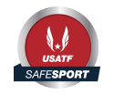
Background Screening / SafeSport Compliant
A new Olympiad year has started make sure you are current / compliant with your Background Screening and/or SafeSport requirements by going to the following link (https://usatf.sport80.com/login). Log in by using your e-mail address and password.

Have and Article or Information to Share?
We would like to hear from our members. Whether it be an announcement, something about an athletic accomplishment or athlete, information about upcoming meets, information for officials or Track & Field trivia, we would like to hear from you. News letters are published three time annually (approximately in March, June, Oct.) so make sure your information is time relevant. Please send your information or article to Mike Nissenbaum at mnissenbaum39@gmail.com in WORD format. Pictures can also be included in JPEG format. We will do our best to include your information or article in one of our upcoming newsletters.

About the Newsletter
This newsletter is being created for the membership to stay in touch with what is happening in the Association. It will provide helpful information, tips and announcements of upcoming events and activities. It will “highlight” the different committees within the Association. Each quarterly edition will attempt to recognize “spotlight on the podium” an athlete, group, member or official. Nominations are welcomed. Please include picture and information. Feedback is welcomed, you can send an email to: mnissenbaum39@gmail.com.

You don’t have to be great to start, but you have to start to be great”
Zig Ziglar

